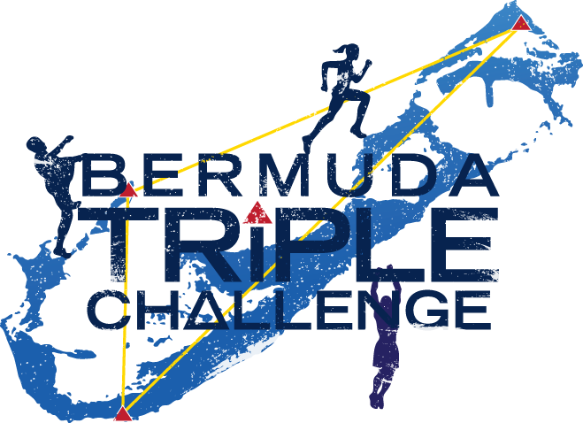
Sponsor Pledge Form
The Bermuda Triple Challenge is a three day weekend obstacle course challenge where teams pledge to complete any one, two or all three obstacle courses in support for the below Bermudian charities. Please pledge your support for them and help teams raise money for charity. Support of Bermuda’s registered charities makes a difference.
Pledges are also accepted online at RacedayWorld.com
https://racedayworld.com/bermuda-triple-challenge/

The Charities
Raleigh International Bermuda: Through overseas expeditions, local training and continued coaching, they challenge young Bermudians to harness their full potential and develop skills for life.
Knowledge Quest: Provides college/university scholarships and mentoring to over 145 Bermudians since 2002, for a positive impact on our economy and our society.
New Beginnings Educational Trust: Supports Bermuda’s “at risk” youth in achieving the new beginnings they have visited for themselves as they re-engage in educational, personal and professional development opportunities.
The Sunshine League: Bermuda’s Oldest Charity, provides holistic and success-driven programs and services for Bermuda’s children and young people. Introducing, “Pathways to Independence” their innovational transitional living program for young men, furnishing them with valuable life-skills and assisting them to achieve their goals with respect to education, employment and permanent housing.
Big Brothers/Big Sisters of Bermuda: A mentoring programme dedicated to helping child and youth primarily from single parent homes, realize their potential by facilitating the development of long-term, one-to-one relationships.
Somerset Primary PTA: Somerset Primary provides quality education in a caring environment that will recognize the various cultural, intellectual and social differences of students with the sole aim of developing the whole child-intellectually, physically, socially, psychologically and spiritually.
I’M A STUDENT
TEAM NAME:________________________ YOUR NAME: _________________________

Here are some suggestions on how you can encourage more donations!

For each Donation Milestone, I am willing to do something just a little bit more, well, crazy!
For each level we (raise and collect BEFORE the events (March 13th-15th) I will do the following:

$100 – <insert something funny/silly here>
$200 – <insert something a little more funny/silly here>
$300 – all the above and <insert something a little more funny/silly here>

This is where it gets good for YOU!
$500 – all of the above and <insert something a little more funny/silly here>
$750 – all of the above <insert something a little more funny/silly here>
$1000 – all of the above <insert something a little more funny/silly here>

This is where it gets good for me!
Between $1000 and $1999 I get to go back to running the event normally! Just shorts, shirt and shoes. Don’t worry I’ll send an update if I’m in this range urging more donations.

This is where it gets REALLY good for YOU!
$2000 – all of the above and <gulp> <insert something a little more funny/silly here>
$4000 – all the above <insert something a little more funny/silly here>
$6000+ – all the above <insert something a little more funny/silly here>

YES – all in the name of charity! Please support our charities

Name | Amount  Pledged | Amount  Received | Official Use
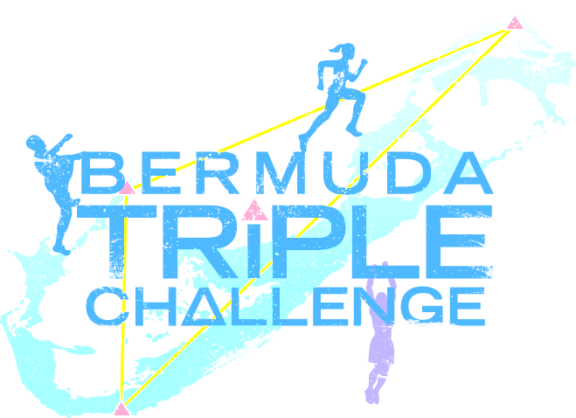

Matching donations by companies count towards your team’s fundraising total if the company’s cheque or its
Letter of Commitment is attached to this pledge form.

